|  |  |  |
| --- | --- | --- |
|  |  |  |

Campaign Information System

Tài liệu Hướng Dẫn Sử Dụng - Học kỳ II

|  |  |  |  |
| --- | --- | --- | --- |
| **Giáo viên hướng dẫn:** | Lê Thanh Nhân | | |
| **Lớp:** | GC0862 | | |
| **Tên nhóm:** | 1 | | |
| **Tên thành viên trong nhóm:** | Tên đầy đủ | | Mã số Sinh viên |
|  | 1. | Võ Minh Nhựt | GC60222 |
|  | 2. | Trần Nguyễn Công Nguyên | GC60263 |
|  | 3. | Nguyễn Ngọc Kiều Trinh | GC60229 |
|  | 4. | Đỗ Ngọc Quý | GC60257 |
|  |  |  |  |

# <05 – 2013>

**USER GUIDE**

**( Group 1 – Campaign Information System )**

**❖System Requirement:**

* SQL Server 2008 or newer
* JDK 1.4 or later.
* Netbeans IDE 6.9 or later [optional]

**❖ Advanced Configuration and Login:**

1. Setup Application base on the enclosed INSTALLATION GUIDE.
2. Run the Application.  
     
     
   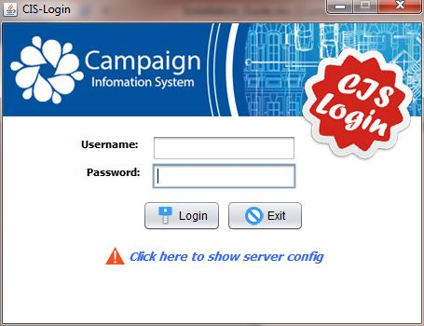
3. Click on the text: “***Click here to show the sever config*** ”.  
     
   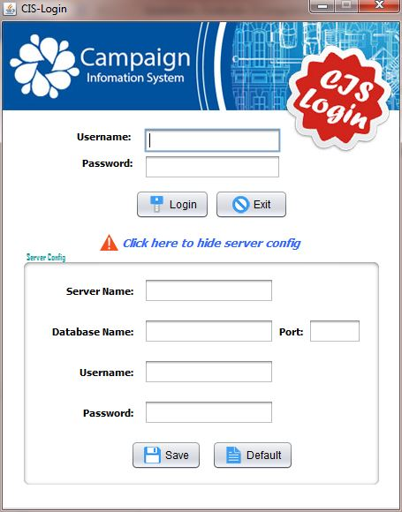
4. 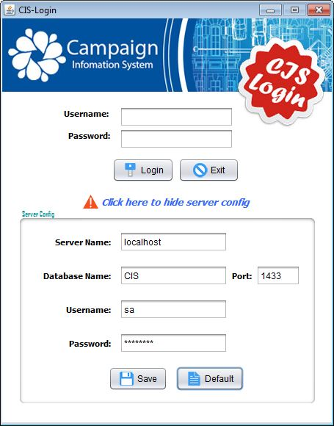Manually input the configuration data or just *simply click the “****Default****” button* to load the prepared one.
5. Click on the “***Save***” button.
   1. Click ***OK*** on the next pop-up dialog to use those inputted configuration data
   2. Click ***Cancel*** to return to the previous step.
   3. **If there is no existed database:** - The application will create a new one for you. 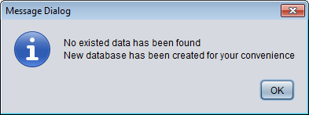
   4. 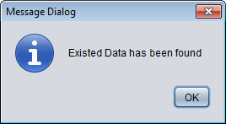**If there is existed database:**
      1. If you want to **use the current database:**
         1. Click ***Cancel*** on the following dialog and *jump to step 8.* 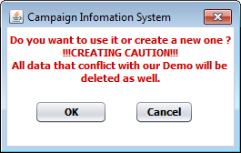
      2. If you want **to create a new session** and dispose all current database:
         1. ‘Click ***Ok*** on the following dialog.
         2. 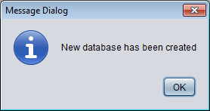The Application will automatically dispose current data and create the new one for you.
6. Click ***OK*** to come back to login window.
7. Input the login-info:
   1. Pre-configured login information:
      1. Administrator:
         1. Username: PR15
         2. Password:123456
      2. Employee:
         1. Username:KS003
         2. 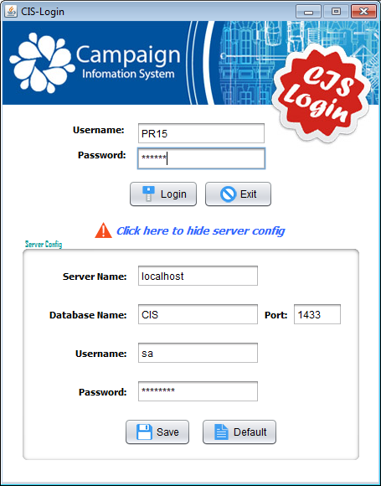Password:123456
8. Click ***Login*** to log in to the application

**MAIN FUNCTIONS OF THE PROGRAM.**

**❖Application Recommended Using Way:**

1. ***Create a Campaign*** base on the appropriate Product and Advertisement solution.
2. ***Input Estimated Data*** for that Campaign.
3. ***Input Actual Data*** for that Campaign.
4. Looking for that Campaign in ***Statistics-Panel.***
5. *Click on**“****View Report****”* to see the campaign’s details.
6. The “***Final Variance”*** is the final result of the application.

* It shows the difference of the actual sale from the estimated one.
* The less this value is the more effectively the campaign is.

**❖Administration’s Features:**

* If you are an Administrator ,you can open all tabs include:

☞ Administration.  
☞ Product Master.  
☞ Campaign Master.  
☞ Advertisement Management.  
☞ Estimated Budget.  
☞ Actual Budget.  
☞ Statistics.

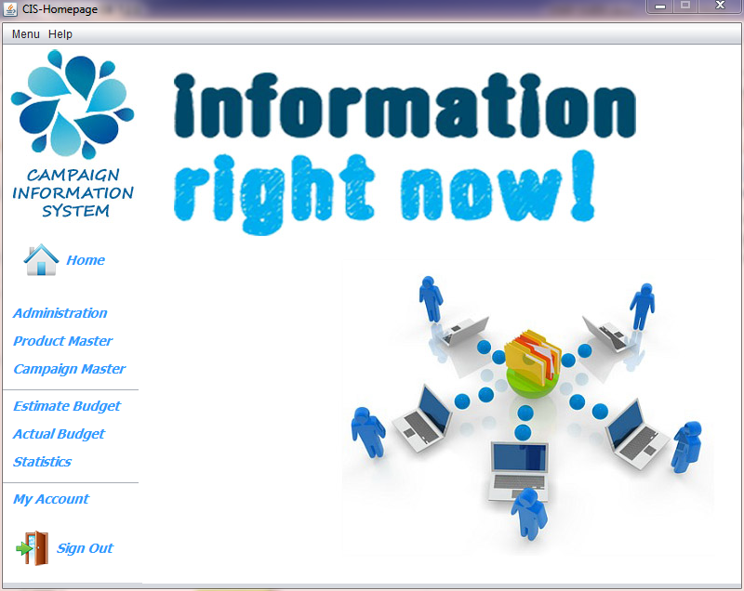

**❖Employee’s Features:**

* If you are an Employee, you can open tabs include:

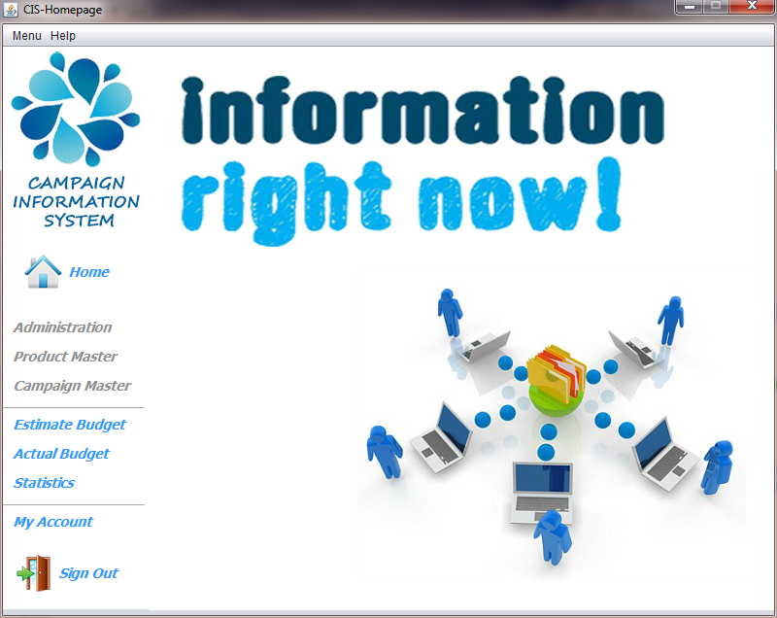☞ Estimated Budget.  
☞ Actual Budget.  
☞ Statistics.

***⮚ Administration( Admin ):***

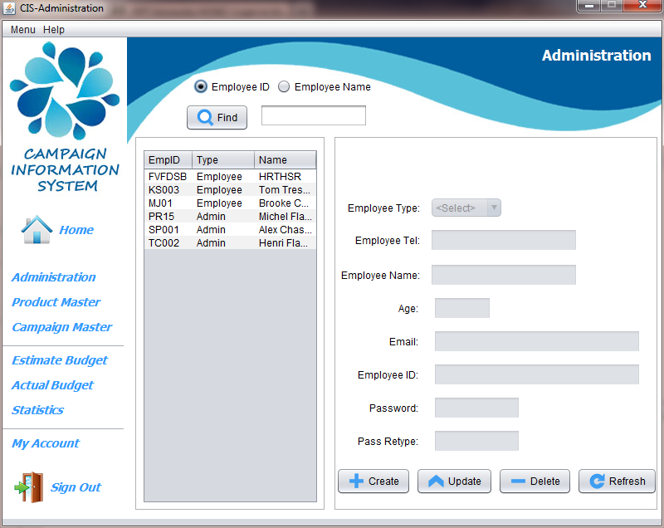

1. **Create a new User:**
   1. Click “***Create***” button.
   2. Choose ***Employee Type*** in the combo box.
   3. Enter information: 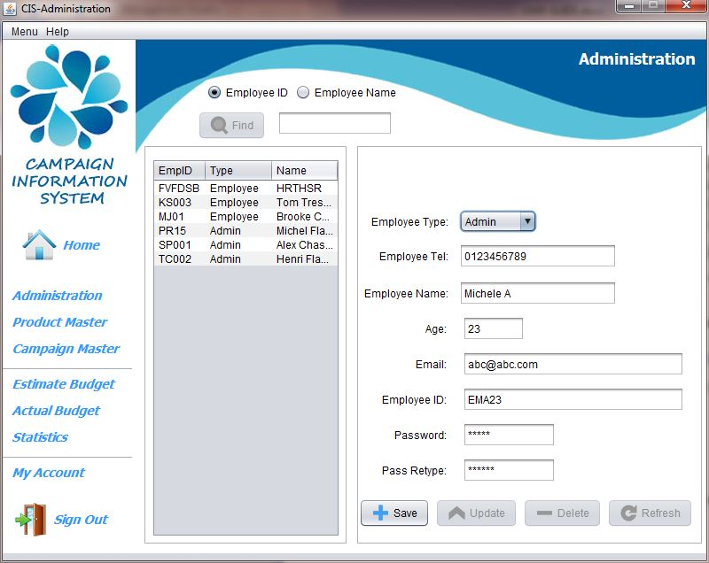
      1. ***Name***: Length must be in between of 0 and 50.
      2. ***Age***: Must be in between of 18 and 60.
      3. ***Telephone*** ***number***: must be valid and length must be in between of 8 and 15 digits.
      4. ***Email***: must be valid .*Example*: [aptech@yahoo.com](mailto:aptech@yahoo.com).
      5. ***ID***: Length must be in between of 0 and 10.
      6. ***Password***: Length must be in between of 6 and 32.

🙞 All fields are not null🙜

* + 1. Click ***Save*** to complete the action.

1. **Update user’s details:**
   1. Choose a user.
   2. Click ***Update*** button.
   3. Input new data follow the creation rule in the previous section.
      1. (Password field is not updateable) 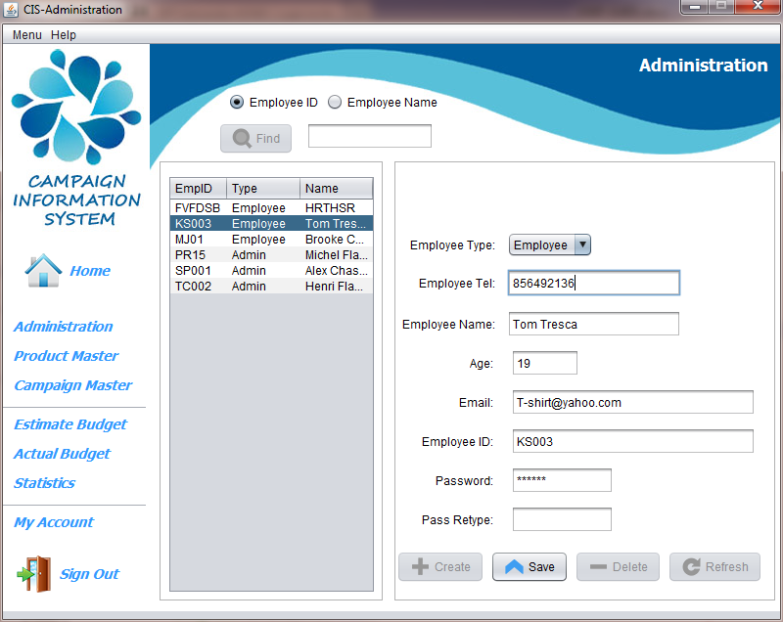
   4. Click ***Save*** to complete the action.
2. **Delete a user:**
   1. Choose a user.
   2. Click ***Delete*** button. 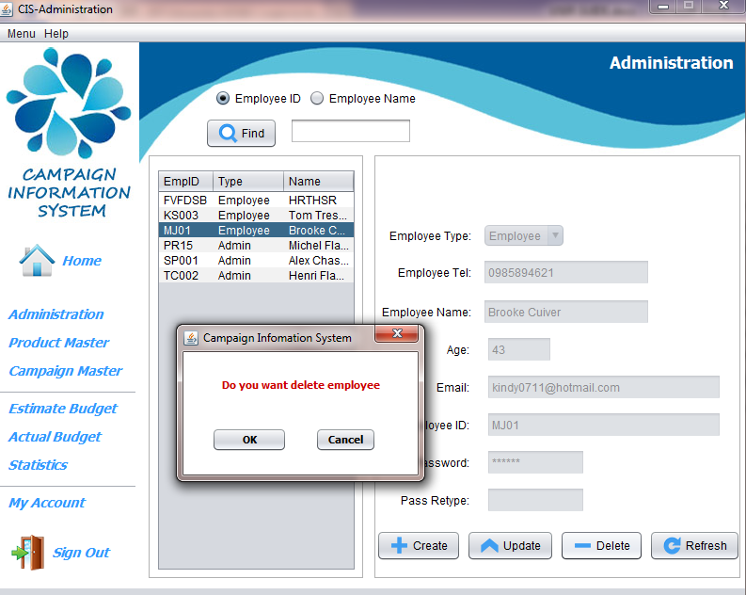
   3. Click ***Ok*** to complete the action or ***Cancel*** to rollback.
3. **Search for a user:**
   1. Enter the Name or ID you would like to search
   2. Click on the appropriate radio button : “***Employee ID***” or “***Employee Name***”.
   3. 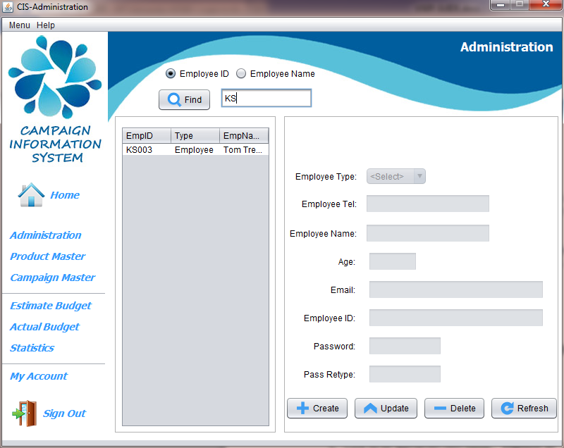Click ***Find*** to complete the action.
   4. When complete, click ***Refresh*** to refresh a page.

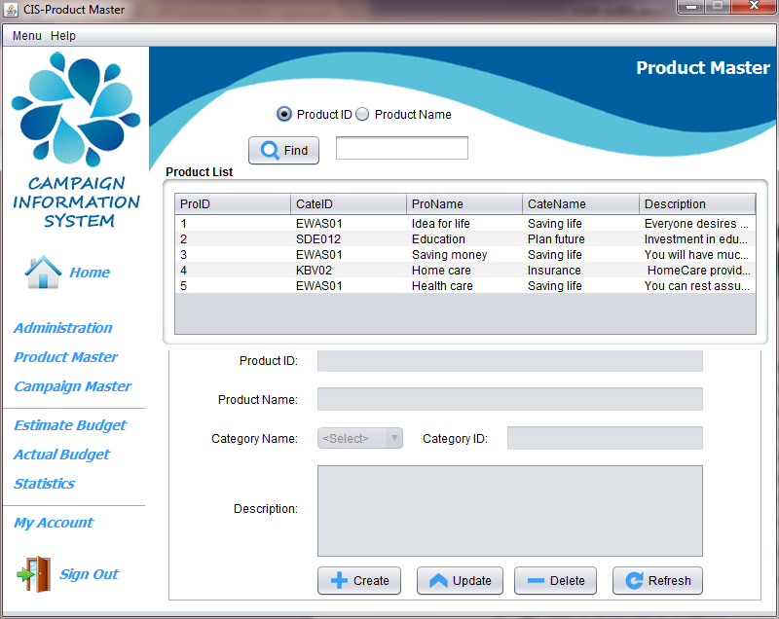***⮚ Product Master ( Admin ):***

1. **Create a product:**
   1. Click ***Create*** button.
   2. Input Product’s data.
      1. ***Product Name***: Length must be less than 50 characters.
      2. ***Category Name***: Must be chosen in the combo box.
      3. ***Description***: Length must be less than 150 characters.

🙞 All fields are not null🙜

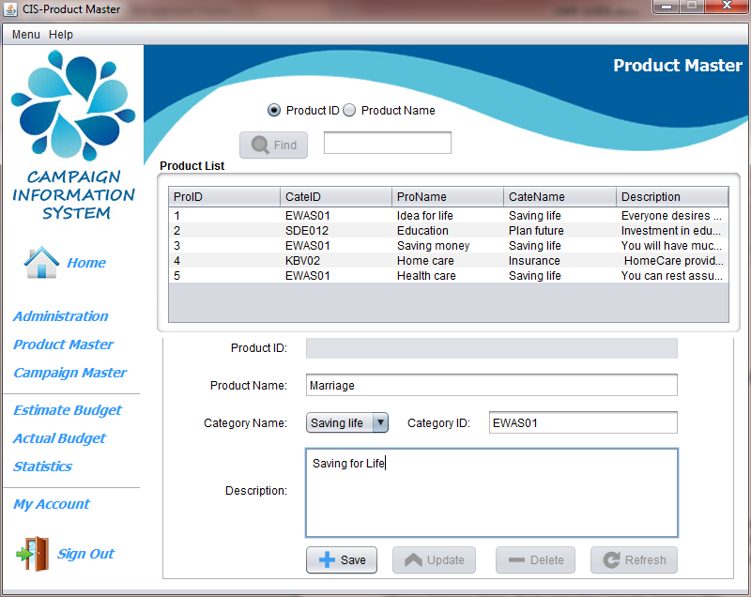

* 1. Click ***Save*** to complete the action.

1. **Update a product details:**
   1. Choose a product.
   2. Click ***Update*** button.
   3. Input new data follow the creation rule in the previous section .   
        
      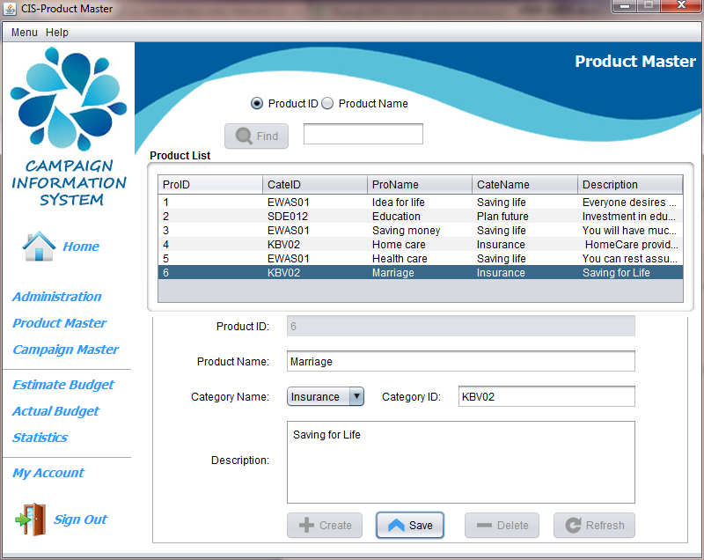
   4. Click ***Save*** to complete the action.
2. **Delete a product details:**
   1. Choose a product.
   2. Click ***Delete*** butt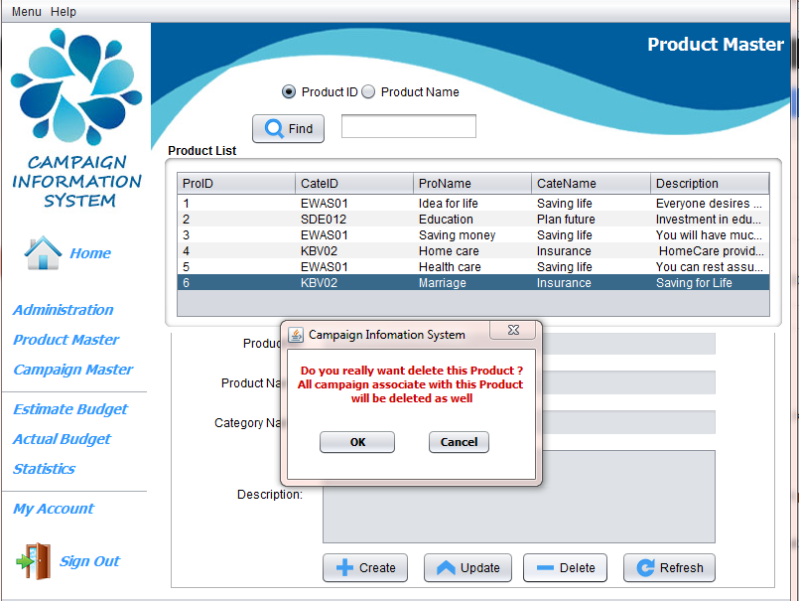
   3. Click ***Ok*** to complete the action or ***Cancel*** to rollback.
3. **Search for a product:**
   1. Enter the Name or ID you would like to search
   2. Click on the appropriate radio button : “***Product ID***” or “***Product Name***”.
   3. Click ***Find*** to complete the action.
   4. When complete, click ***Refresh*** to refresh a page.

***⮚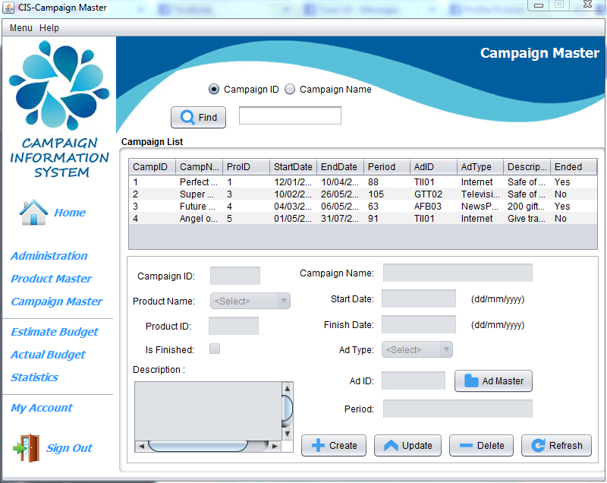 Campaign Master(Admin):***

1. **Create a campaign:**
   1. Click ***Create*** button.
   2. 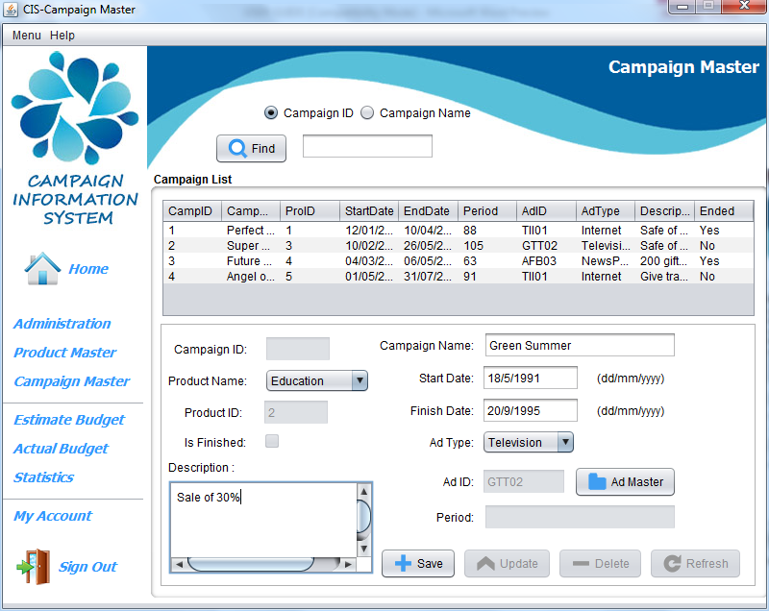Input Campaign’s data.
2. ***Start Date & End Date*** : must type DD/MM/YYYY

Example: 12/4/1994 or 12/04/1994

1. ***End Date*** : must after Start Date
2. ***Campaign Name* :** Length must be less than and 50.
3. ***Product Name*** : Must be chosen in the combo box.
4. ***Advertisement Type*** : Must be chosen in the combo box.
5. ***Description:*** Length must be less than and 150.
   1. Click ***Save*** to complete the action
6. **Update a campaign:**
   1. Choose a campaign.
   2. Click ***Update*** button.
   3. 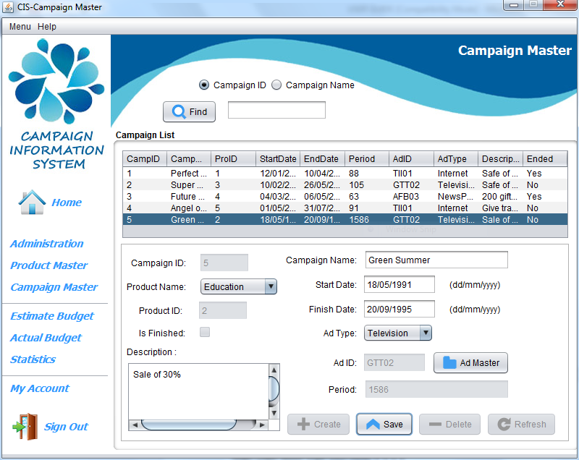Input new data follow the creation rule in the previous section.
   4. Click ***Save*** to complete the action.
7. **Delete a campaign:**
8. Choose a product.
9. 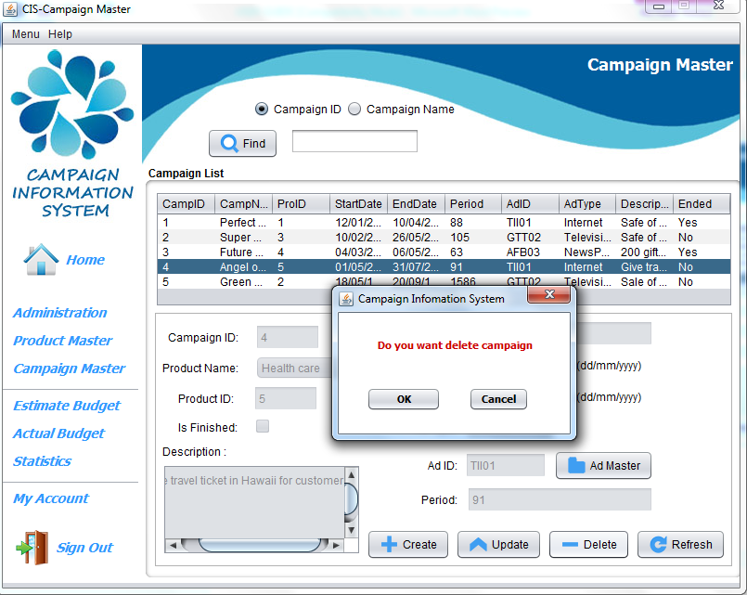Click ***Delete***button.
10. Click ***Ok*** to complete the action or ***Cancel*** to rollback.
11. **Search a campaign:**
12. Enter the Name or ID you would like to search
13. Click on the appropriate radio button: “***Campaign ID***” or “***Campaign Name***”.
14. 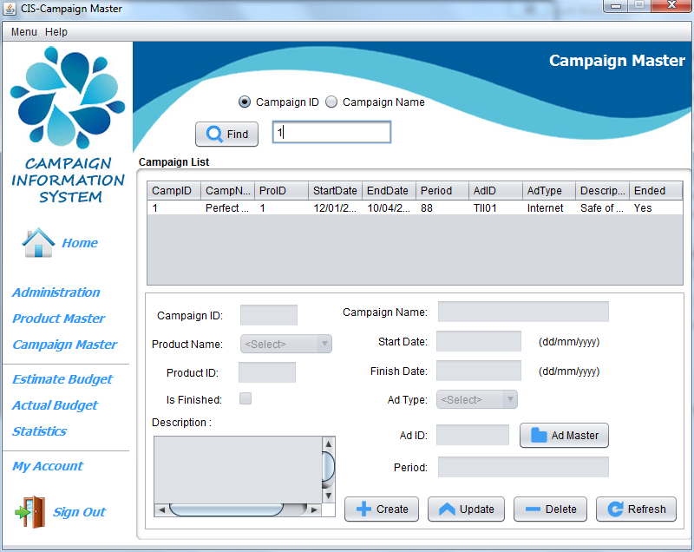Click ***Find*** to complete the action.

***⮚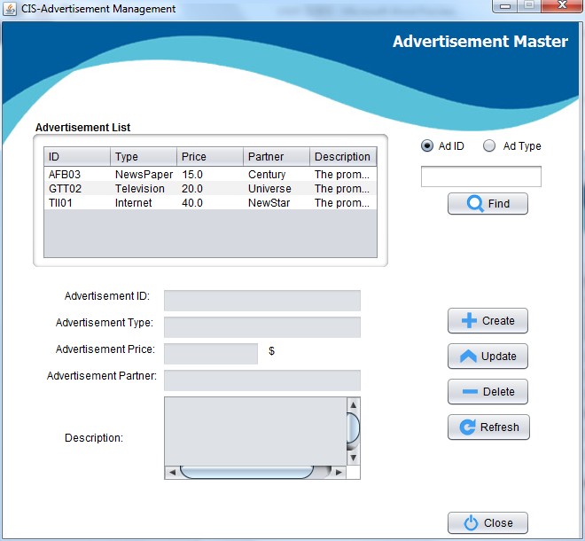 Advertisement Management(Admin):***

1. **How to open Advertisement Master's Features :**

* ****Click ***Ad Master*** to go to Advertisement Master's Features

1. **Create an Advertisement:**
   1. Click ***Create*** button.
   2. 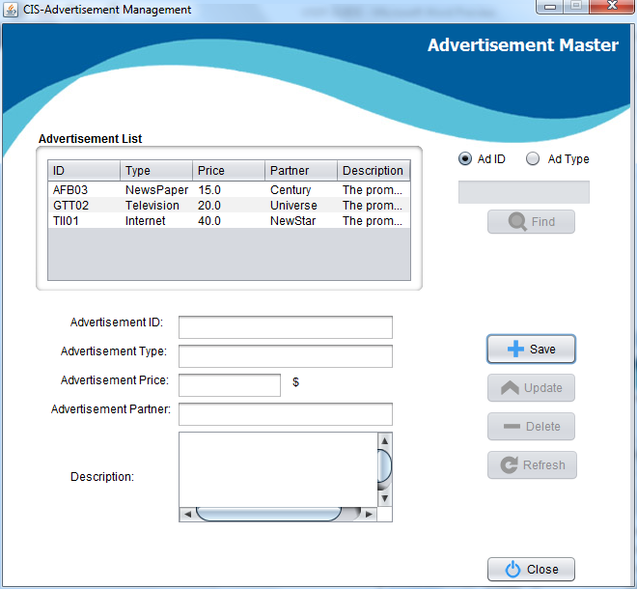Input Advertisement’s data.
      1. ***Advertisement ID***: Length must be less than 10.
      2. ***Advertisement Price*:** Value must be in between of 0 and 100000.
      3. ***Advertisement Partner*** : Length must be less than 30
      4. ***Description***: Length must be less than 150.

All fields are not null

* 1. Click ***Save*** to complete the action

1. **Update an Advertisement:**
   1. Choose an Advertisement.
   2. Click ***Update*** button.
   3. 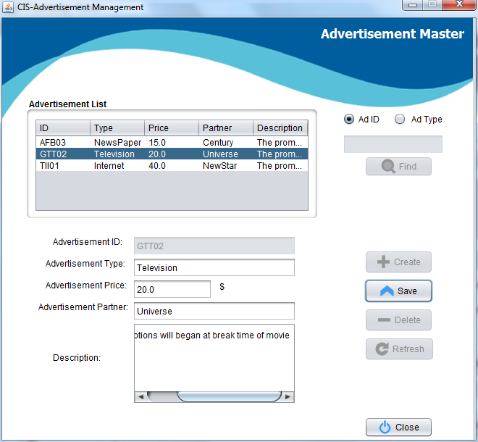Input new data follow the creation rule in the previous section.
   4. Click ***Save*** to complete the action.
2. **Delete an advertisement:**
3. Choose a product.
4. 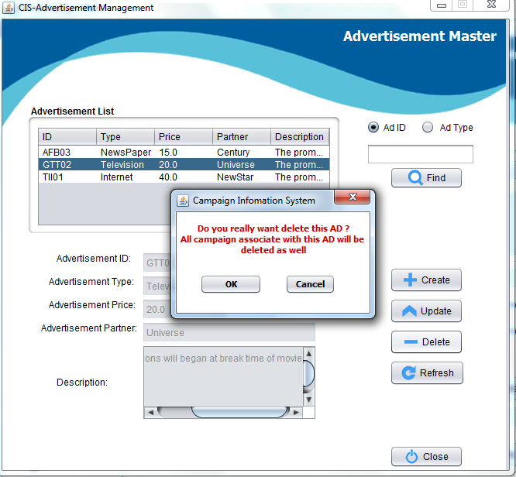Click ***Delete***button.
5. Click ***Ok*** to complete the action or ***Cancel*** to rollback.
6. **Search an advertisement:**
7. Enter the Name or ID you would like to search
8. Click on the appropriate radio button : “***Ad ID***” or “***Ad Type***”.
9. Click ***Find*** to complete the action.

⮚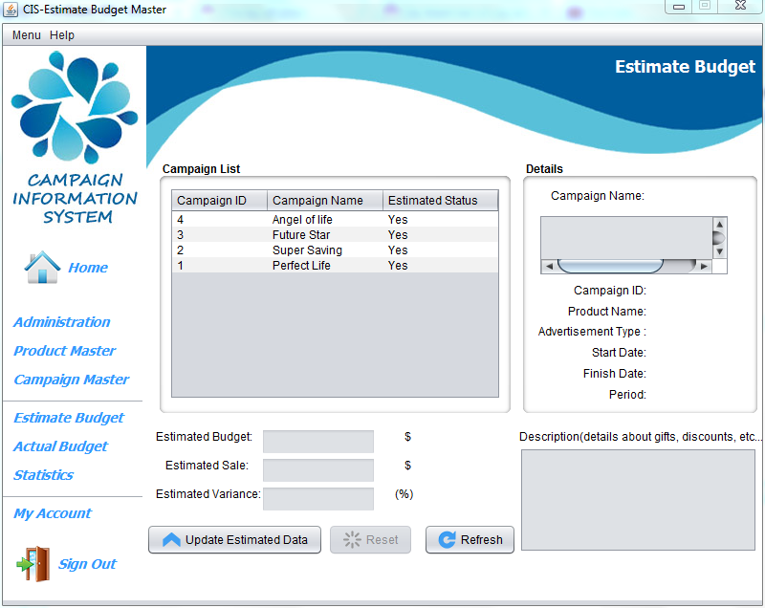 ***Estimate Budget Master(Admin Employee):***

**Update an Estimate Budget:**

1. Choose a campaign.
2. Click ***Update Estimated Data*** button.
3. 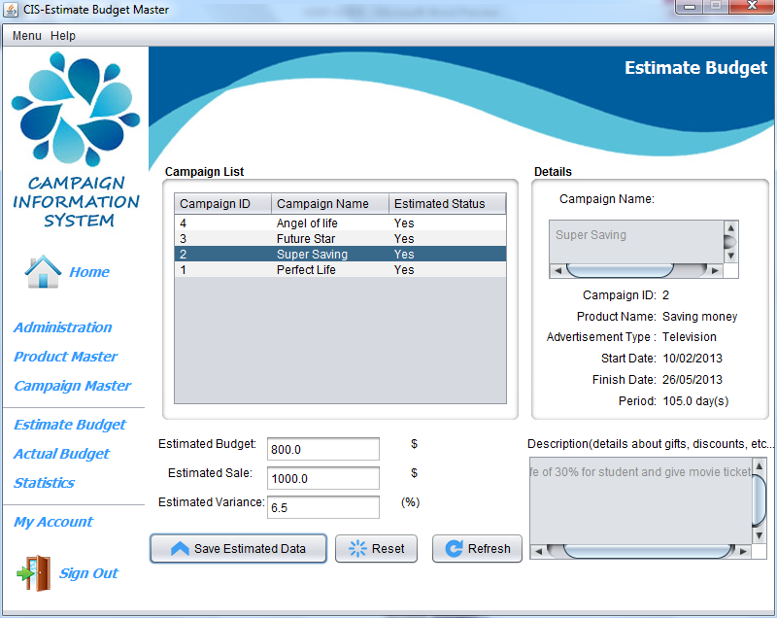Input new data follow this update rule in there

(*) Click ***Reset*** if you want to blank all field

**Estimated Budget :** Value Range is from 0.1 to 100000.0

**Estimated Sale :** Value Range is from 0.1 to 100000.0

**Estimated Variance :** Value Range is from 0.1 to 100.0

All fields are not null

1. Click ***Save*** ***Estimated Data*** to complete the action

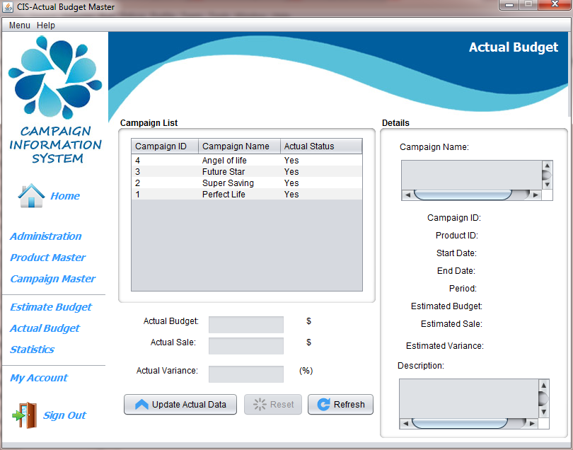***⮚*** ***Actual Budget Master(Admin & Employee):*Update an Actual Budget:**

* 1. 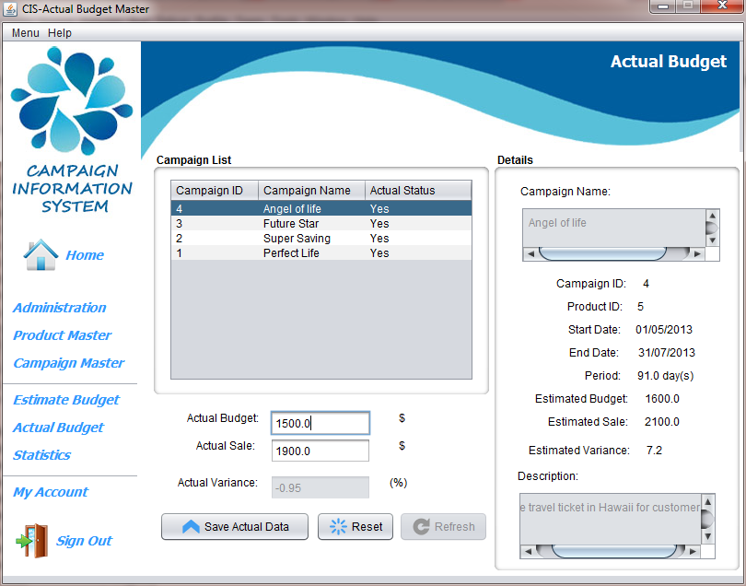Choose a campaign.
  2. Click ***Update Actual Data*** button.
  3. Click ***Reset*** if you want to blank all fields.
  4. Input new data follow this update rule in the following:

**Actual Budget :** Value Range is from 0.1 to 100000.0

**Actual Sale :** Value Range is from 0.1 to 100000.0

All fields are not null

* 1. Click ***Save*** ***Actual Data*** to complete the action

***⮚ Statistic Report (Admin & Employee):***

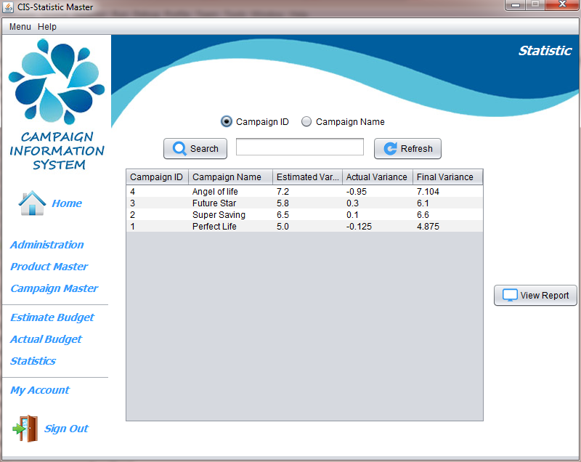

(*) Click ***Refresh*** to refresh information

1. **Search details:**
   1. Enter the Name or ID you would like to search.
   2. Click on the appropriate radio button : “***Campaign ID***” or “***Campaign Type***”.
   3. Click Search to search for campaign information.

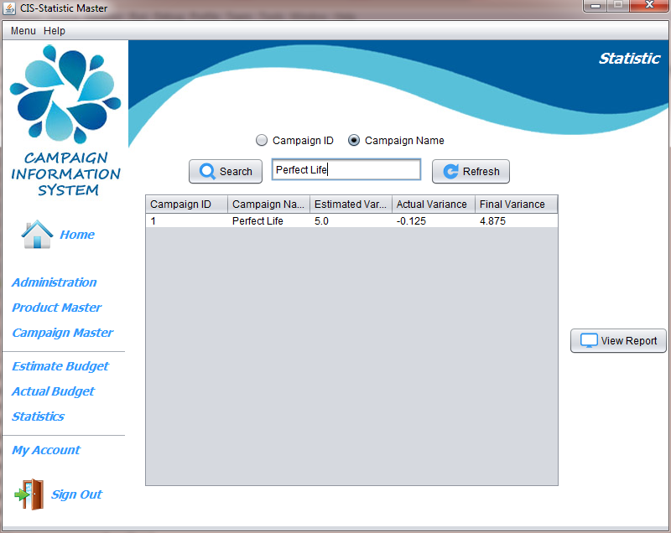

1. **View Report Information:**
   1. Click on a Campaign.
   2. 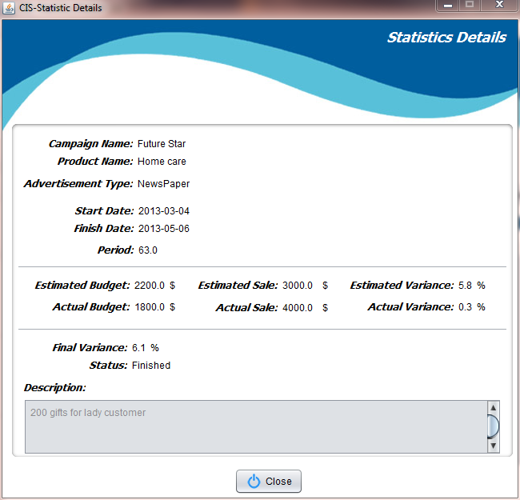Click View Report to go Statistic Details.
   3. Click Close to go previous Form.

***⮚ My Account (Admin & Employee):***

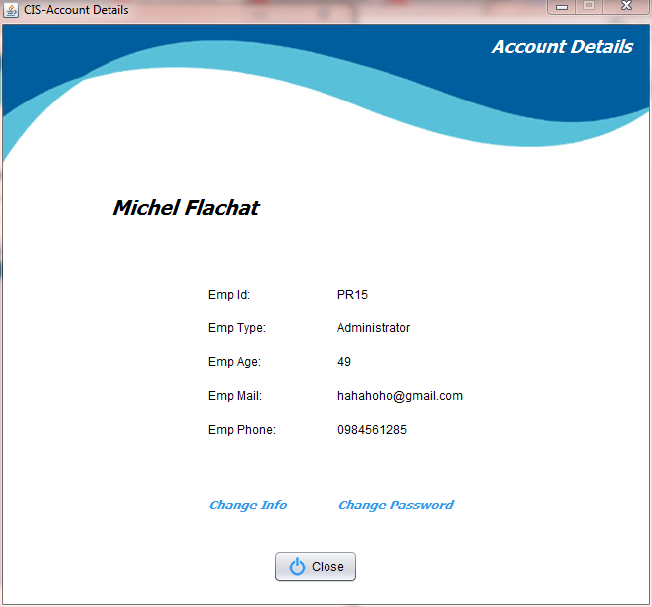

1. **Change Information:**
   1. Click the text “***Change Info***” to change your account information.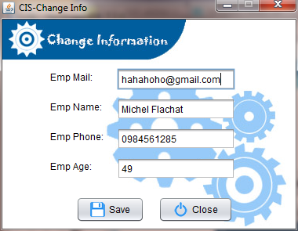
      1. ***Employee Mail:*** Length must be less than 50 character.
      2. ***Employee Name:*** Length must be less than 50 character.
      3. ***Employee Phone:*** >=8 and <=15 digits.
      4. ***Employee Age:*** must be in between of 18 and 60.

All fields are not null

* 1. Click ***Save*** to complete the action.
  2. Click ***Close*** to go Previous Form.

1. **Change Password**
   1. 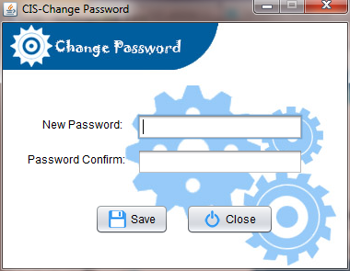From Account Details click the text “Change Password” to change your password.
      1. New Password: Length must be less than 40.
      2. Confirm Password: must match your new Password.

All fields are not null

* 1. Click Save to complete the action.
  2. Click ***Close*** to go Previous Form.

1. **Click Close to go Home Page.**